The Ruth Miskin website is a fantastic resource to support parents/carers with information about phonics and the RWI program -
https://www.ruthmiskin.com/en/find-out-more/parents/
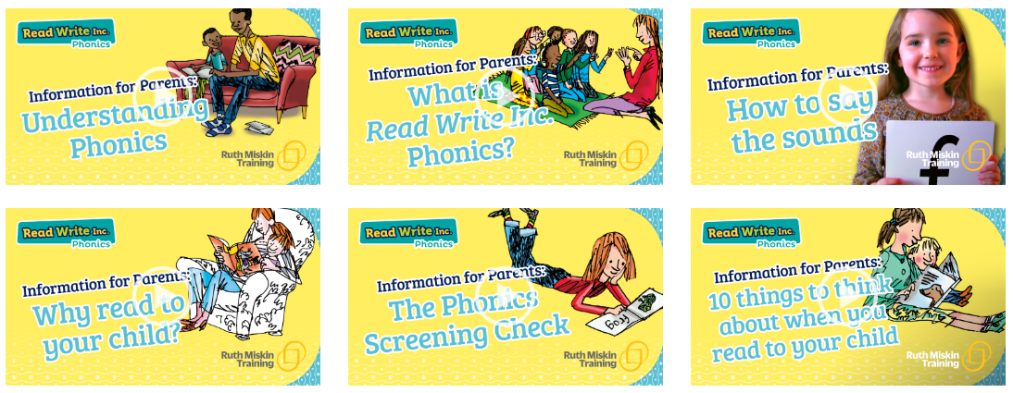
This website is also offering free RWI phonic lessons daily –
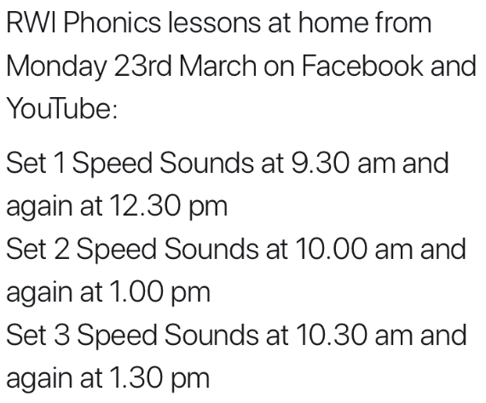

Phonicsplay website is good for the children to use to practise reading real and nonsense words. At present parents are able to subscribe for free –
Username – march20
Password - home
https://www.phonicsplay.co.uk/
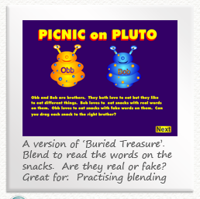
The Picnic on Pluto game is great (Phase 5).

Teach you monster to read is another great resource to support phonics and reading
https://www.teachyourmonstertoread.com/
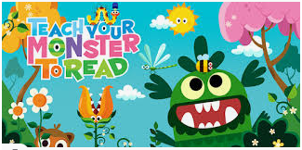

Oxford Owl are offering 1000s of free ebooks
https://www.oxfordowl.co.uk/for-home/find-a-book/library-page
