- Make sure you have installed the Zoom desktop client (and are not using Zoom in your browser only). If you haven’t done this before, go to https://zoom.us/download and select the top option:
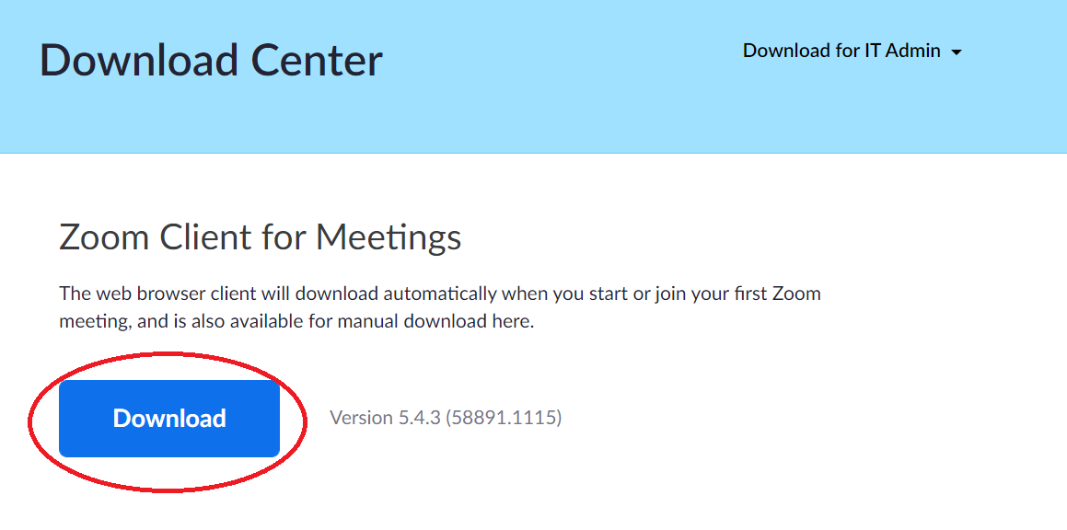

- When you have successfully downloaded and installed it, you will see this icon on your desktop:

- Double click on it and log in with your Zoom username and password
- When you are logged in, you will have the following options along the top:

- If you click on Chat, you will see a box at the top left called ‘Jump to’:

- If you click in this box, you can search for another user. Any matches will come up underneath – you will also see their status symbol against their name here:
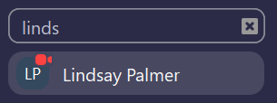

- The little symbol next to the name indicates the user’s status. You can find a list of these here https://support.zoom.us/hc/en-us/articles/360032554051-Presence-status

- Click on their name to start a chat with them:
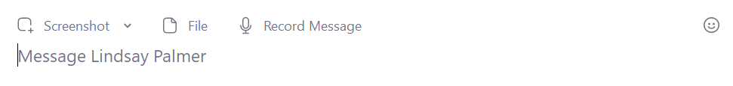

- NB: if you send a message to someone who is not logged in to Zoom, they will not receive it until they do log in
- You must be logged in to Zoom to receive Chat messages. When you are, your Zoom icon in your task bar will flash:

- Click on the icon to open up Zoom and respond to the Chat

- If you click on Contacts at the top, you will see a list of everybody who has a Zoom account within our organisation, listed alphabetically by first name:
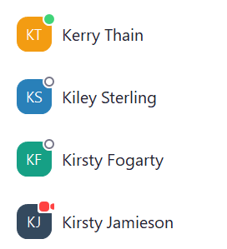

- Again, the little symbol next to the name indicates the user’s status
- There is also the option to click on Channels, in the top left corner:
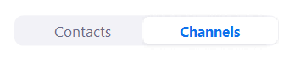
- In Zoom, a Channel is a group chat. If you have been added to a Channel by someone else, you will see it listed here

- You can also start your own Channel, by clicking the + sign next to Channels and then clicking on Create a Channel:

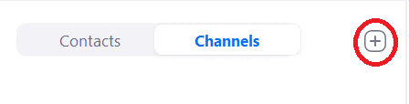
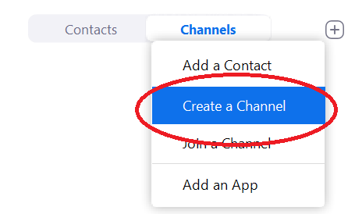
- Set up your Channel by giving it a name, deciding whether it is Public or Private, and whether people from outside our organisation can join (only people who are employed by The Mead Academy Trust are inside our organisation):
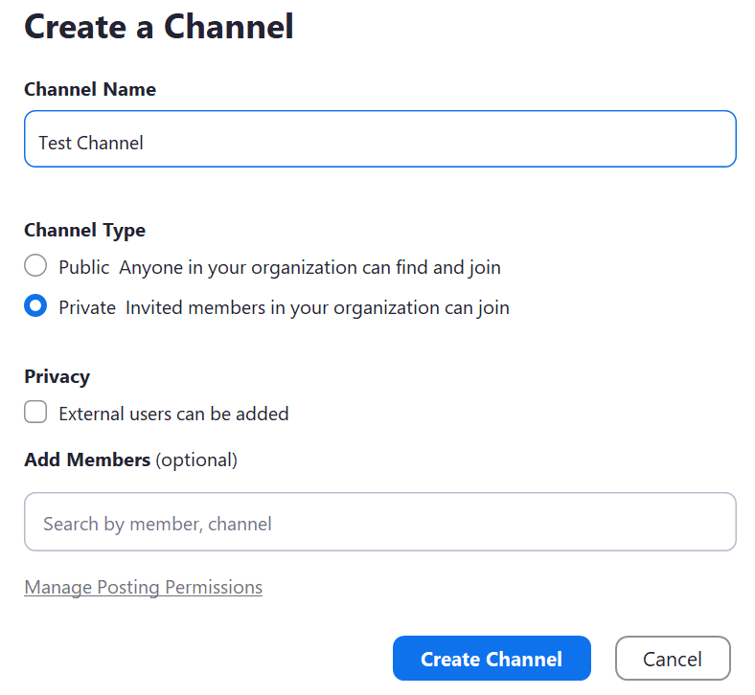
- Add people to your Channel by typing their name in the Add Members section. As with ‘Jump To’, start typing their name to find possible matches:

- Click Create Channel
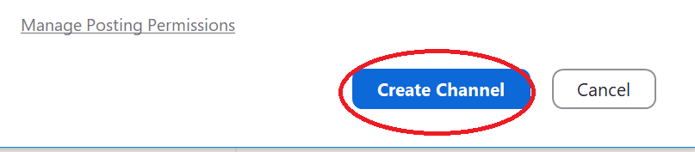

- Your Channel will open, and you can then send messages to everyone within that Channel – and they can reply

Some useful things to know…

- If there is someone you want to chat to frequently, you can ‘Star’ them. They will then be pinned to the top of your Chat window, so you can find them quickly. Do this by hovering over their name in the left hand Chat panel, and click on the arrow on the right. Then choose ‘Star this Contact’:
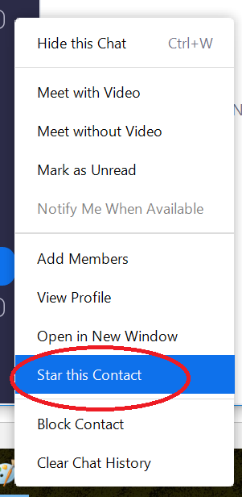

- If you are in a Chat with someone and decide you want to talk instead, just click the Meet With Video icon in the top left of the Chat window. You don’t need to schedule a new Zoom meeting with them:
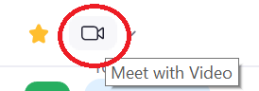

- All Chat messages (including those edited or deleted) sent and received in a Mead Academy Trust organisation account are saved on the cloud for 1 year, and would be accessible to the Executive Leadership Team to view if required
- All Chat messages sent and received in a Mead Academy Trust organisation account will be saved on your local device (phone or laptop) for 1 month. After this time they will be automatically deleted – you should not use Chats to save or store anything important that you will want to access after 1 month
- You can use Zoom on your mobile in exactly the same way as on your laptop / desktop computer. Just download it from the Apple or Android app store like any other app, and then follow the instructions above

