

The Mead Academy Trust

CPOMs reporting system

All members of staff are required to follow this procedure as part of our Safeguarding and Behaviour policies from

**September 2020**

The Mead Academy Trust: a company limited by guarantee

**Registered in England: Company Number: 08024396**

Registered Office: The Mead Community Primary School, Hackett Place, Hilperton, Trowbridge, Wiltshire, BA14 7GN

CPOMS is very straight forward electronic reporting system and we use it for a variety of reasons:

* It enables us to share information quickly and provides a record that we have shared and acted upon information received.
* It enables us to link safeguarding and behavioural concerns.
* CPOMS is new to our school, please refer to this guidance - but also do ask for help if unsure. The guidance looks more complicated than the actual process in practice. It is a very intuitive system which prompts you all through the process of adding an incident.
* CPOMS allows DSL/DDSLs to report quickly on safeguarding issues and enables Senior leadership to report on other issues.
* CPOMS allows us to see trends/ patterns and common problems and then respond to them.
* CPOMS will provide evidence to consider when directing classroom support and SEN provision for the coming year.
* Categories have been added requiring us to understand and use correct terminology, these should be familiar to you from your school training and the use of our previous paper system.
* You cannot do anything wrong on CPOMS if you categorise something inaccurately, the DSL/DDSL or member of the leadership team will tag it differently.
* The use of CPOMs will be reviewed and revised at the end of the year in light of our user experience.

All concerns are reported on CPOMS. All staff will be trained in how to do this. Good reporting is done using professional language and from an objective viewpoint. This system has been developed to reflect our best practice and the various sections replicate our previous paper concern sheets.

**Disclosures from children**

* **must be reported verbally, straight away to the DSL/DDSL.**
* **if a child is at risk of harm or you suspect a child is at risk of harm, it needs acting upon quickly.**
* **if you are on you own with children at the time, a red card must be sent to the office and you must ask them to get you a DSL quickly.**
* **you must then report it on CPOMS later, unless advised to do differently.**

**If unsure, seek a DSL/DDSL immediately for advice. Reporting does not get anyone into trouble- NOT reporting does**

**Logging on for the first time**

CPOMS can be accessed from any internet enabled computer, laptop, ipad or chromebook from one of the following locations:-

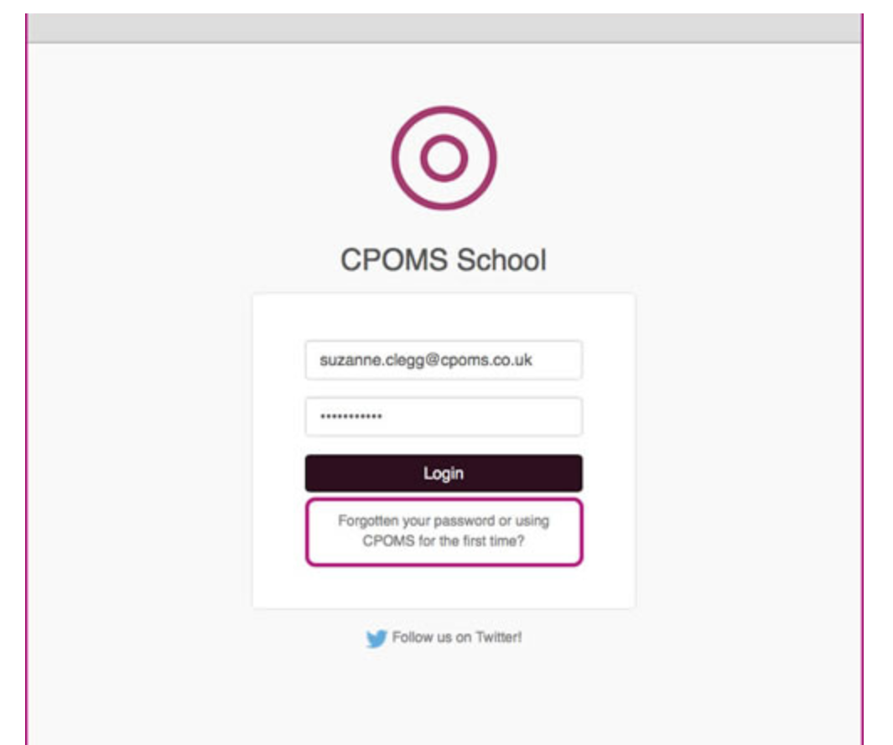

[https://themead.cpoms.net](https://themead.cpoms.net/)

[https://castlemeadtrowbridge.cpoms.net](https://castlemeadtrowbridge.cpoms.net/)

[https://rivermead.cpoms.net](https://rivermead.cpoms.net/)

We plan to have a shortcut link on the home screen of all devices in school. You may be able to help us with that! If when you log on for the first time there is no shortcut on the home screen and you feel confident to add one please do, thank you.

To ensure optimum security all members of staff must firstly create their own password.  This can be done by selecting the ‘**Forgotten your password or using CPOMS for the first time?**’ option beneath the ‘Log in’ button.  Simply input your work email address and click ‘Reset Password’.  This will then send you a link to your email address where you can create your first CPOMS password.

**Reporting a concern or incident**

Once logged on to the system to report a concern/incident:

* **Add Incident –** click on the ‘Add Incident’ at the left hand side of the screen (click on the words not the drop down arrow as that adds something different.

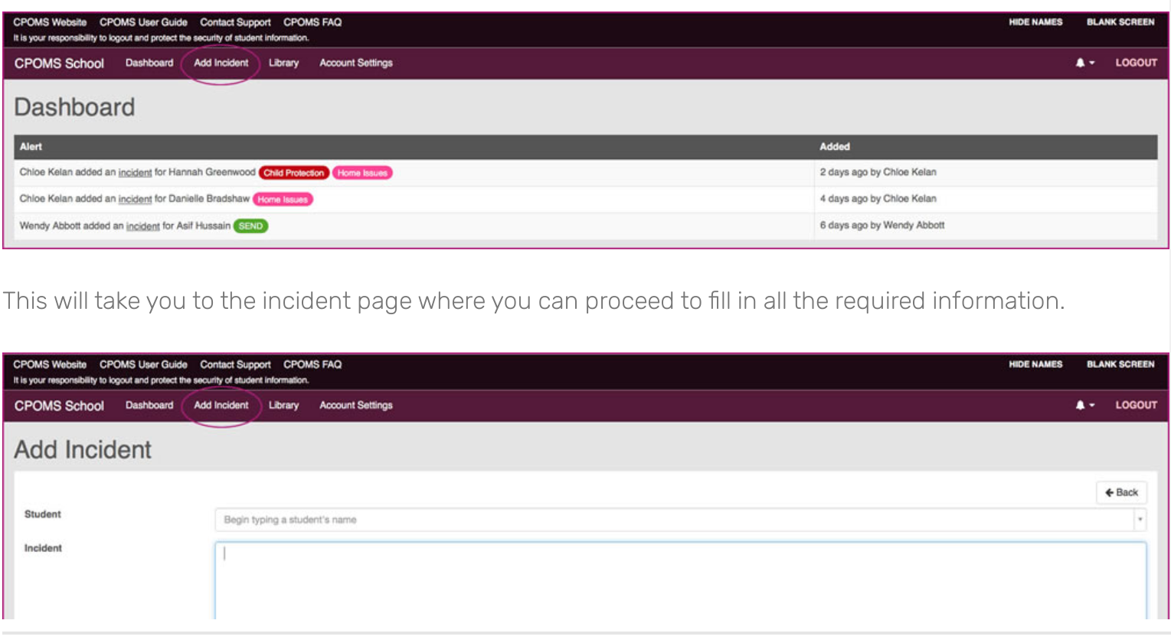

* **Student** - click in the student box and beginning to type their first name, then choose the correct name and surname from the drop down list
* **Categories** - then choose your categories from the following list. It is possible to select more than one category
  + - Behaviour
    - Bullying
    - Prejudicial
    - Safeguarding
* **Sub-categories –** when you tick any of the categories a number of boxes will appear for additional information appropriate to the category/ies you have selected. There is more information on the content of sub-categories at the end of this guidance.
* **Day of the Week –** this is important so that we can to look for patterns
* **Session –** this is important for considering patterns and other factors
* **Date/time –** Dates and times are really important. CPOMS will automatically show the date and time at the point you are reporting. Change this by clicking in the time box and typing the correct time. You will change the date less frequently as we write reports on the same day as they happen. **NB:** DO NOT press enter on your keyboard when you change the date/ time as this will add your incident before you have completed the next stage.
* **Location of Incident –** choose from the drop down options.

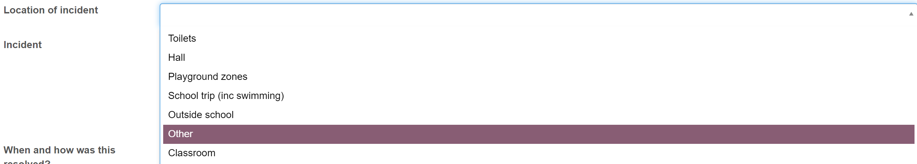

* **Incident -** write in the incident box. If you action, or give a negative consequence for any incident (e.g. behaviour), you also need to write this in the incident box.

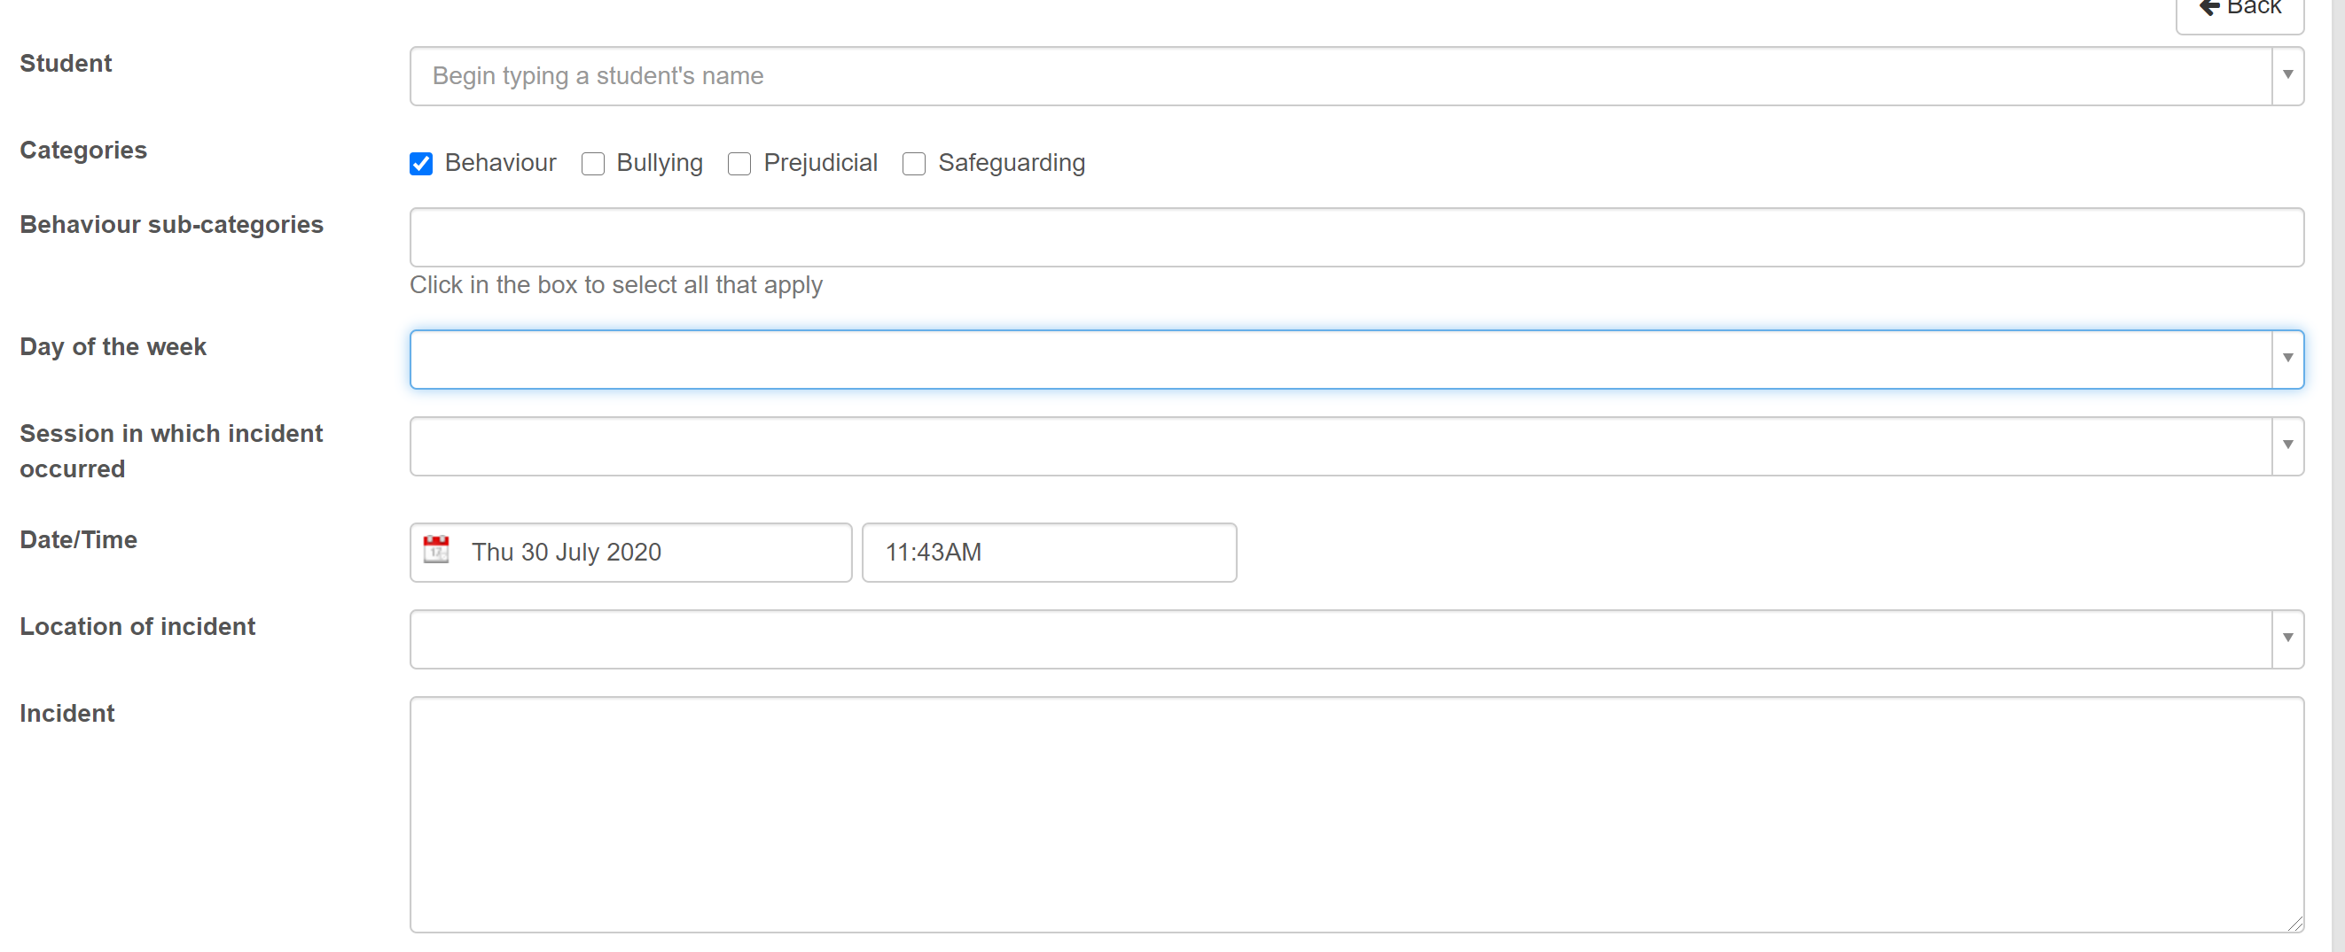

* **Body Map –** use where appropriate to **any** concern. Click on the arrow at the right of the box. This shows a front and back view of a child’s outline. If a child has an injury or mark, you can indicate where by clicking in the appropriate place on the body map. If you do this incorrectly, you can correct it.



* **Linked Student/s -** Once the above steps have been completed, you can link other children by starting to type their name in this box. As you type, a drop down box will appear and you will be able to click on the correct name. This enables you to write an incident once and for it to be shared into the records of other children who were involved. This saves writing the same incident more than once.



* **Status –** choose **active** where unresolved or **closed** where you consider there is no further action needed.
* **Assign to –** from the drop down box select the appropriate member/s of your leadership team ie **DSL/DDSL** **for safeguarding** or **DHT for behaviour**



* **Files -** If you want to upload a file to accompany this report, e.g. a letter or note. This can be done through clicking on the ‘click to browse or drag a file to upload.’



* **Alert -** The next step is to alert (tag) the relevant staff **if that seems appropriate** eg a class teacher if they are not already aware of a behaviour incident. Do so by starting to type their name in the box. The box will drop down to show names and the correct one can be selected. You can notify more than one person.
  + **ALWAYS** be mindful of the need for confidentiality when making your decision. If you are unsure don’t add or ask advice. The member of staff receiving your concern/incident can alert others if deemed necessary.
  + **ALWAYS** include the Head of School for **ALL** reports.



* **Agency involved –** you do NOT need to add anything to this box
* **Add to planner –** if you want your own reminder to follow the concern/incident up you can click on this box and then you can choose a date and time for your email reminder. You can click in the text box to add any further information for yourself when you receive the reminder.

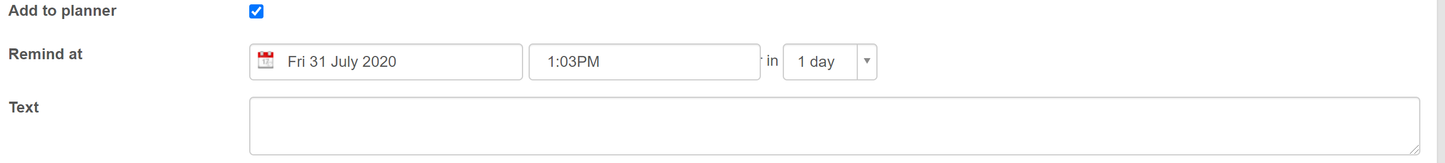

* **Add Incident -** When you have completed your form, click the ‘Add Incident’ icon. Once you have done this, you will not be able to access it again.



* **What happens next? -** 
  + Sometimes an incident will need an action by the person who receives the notification or they may direct another person to. They will add the action onto your report. You will only see this action if you are tagged in it.
  + If there is an action for you, you will receive a message to alert you or the leader will tell you.
  + If you do not see an action, it does not mean that one has not taken place. Where appropriate you will be tagged in any action (undertaken by someone else) to your report.
  + If you ever have any query about a concern/incident or an action always ask a member of the leadership team.

**Categories and Sub-categories**

As described above there are 4 main categories that reports will be tagged as (CPOMS refers to them as ‘parent categories’). When you click on one of these main categories, sub categories will be shown. These sub-categories reflect those in our previous paper reporting forms and are outlined below for your reference.

**Behaviour Category:**

* **Sub-categories**
* Physical harm pupil
* Physical harm adult
* Verbal abuse adult
* Verbal abuse pupil
* Damage
* Persistent
* Defiance
* Disruption
* Other

In the Behaviour section there are other drop down boxes to complete:

* **De-escalation strategies used** – there is a drop down list for you to select ALL the strategies that you used

from this list

* **Outcomes of incident** – there is a drop down list for you to select ALL the outcomes. These include:
  + Someone suffered verbal harm
  + Someone suffered physical harm
  + A Positive Handling Intervention was required
  + First Aid administered to and adult – you can include this even if you are not the person who administered it
  + First Aid was administered to a child– you can include this even if you are not the person who administered it
  + Aggressive incident
  + Accidental harm
  + Someone was hurt (near miss)

Once you have reported the incident you may be asked to complete additional forms and will be supported with that

**Bullying Category:**

* **Sub-categories**
  + Having personal possessions taken or damaged
  + Being forced into something against their will
  + Being isolated (including being ignored or left out)
  + Experiencing online bullying (including text, emails, social media etc)
  + Others spreading rumours / nasty notes
  + Experiencing physical abuse
  + Being forced to hand over money
  + Other (please specify)

In the Bullying section there are other drop down boxes to complete:

* **Details of investigation:** select all that apply
* **Further measures taken:** a free text box for you to type in.

**Prejudicial Category:**

* **Sub-categories**
  + Race
  + Sexual orientation/homophobic
  + Disability related
  + Ethnicity
  + Religion
  + Gender
  + Derogatory
  + Gender re-assignment
  + Age related

**Safeguarding Category:**

* **Sub-categories**
  + Emotional abuse
  + Neglect
  + Sexual abuse
  + Inappropriate use of technology
  + Domestic abuse
  + Drug/alcohol abuse
  + Self-harm
  + Family breakdown
  + Child sexual exploitation
  + Child criminal exploitation
  + Mental health
  + Physical health
  + Police involvement
  + Residency issue
  + FGM
  + Physical abuse
  + Other

**PLEASE BE AWARE THAT WE HAVE SAFEGUARDING INFORMATION IN THE STAFFROOM AND THIS IS UPDATED FREQUENTLY**